I B.Tech II Semester Regular Examinations – June, 2024

PROBLEM SOLVING THROUGH PROGRAMMING-II

(BI/BIOTECH/BME/CHEM/CIVIL/CSE/CS)/ CSE(ds)/CSE (ai&ml)/ECE/EEE/ FT/ MECH/ R&A)

Time: 150 Min Max. Marks:80M

SECTION - A
Answer all Four questions 4×10M=40M

- Discuss the need of pointer arithmetic. What arithmetic operations are allowed on pointers? Develop a code snippet to illustrate the pointer arithmetic. (3M)
- Consider a 1-dimensional array of characters char str[] =” I Love India”. Develop code snippets that perform the following. (4M)
- Display the string contained in str using pointer notations. Do not simply print the string using printf() function.
- Reverse the string using pointer notations. Do not use any library function to reverse the string.
- Using pointer notations develop a code snippet to perform the following.
- Given two strings s and goal, return true if and only if s can become goal after some number of shifts on s.
A shift on s consists of moving the leftmost character of s to the rightmost position.
For example, if s = "abcde", then it will be "bcdea" after one shift.
Example 1:
Input: s = "abcde", goal = "cdeab"
Output: true
Example 2:
Input: s = "abcde", goal = "abced"
Output: false (3M)

- A file must be opened before data is written to or read from it, and it must be closed after its purpose is over. Name the library functions that perform these two tasks. Write the syntax of these two functions. (3M)
- Develop code snippets to perform the following tasks. (4M)
- Write the sentence, “I will appear for summative exams in May, 2024.” into a file called “text.dat”
- Count the number of words in the file, “text.dat”.
- Assuming a text file with a line of text, “I will appear for summative exams in May, 2024.” already exists; develop a program to perform the operations.
- Read the sentence from the file and copy it into a string array such that the sentence appears in the reverse as, "2024 May, in exams summative for appear will I."
- Print all the words in the reversed sentence that begin with a vowel and contain two or more characters. (3M)

- What is the purpose getc() and putc() functions? Write their syntax. (3M)
- Develop code snippets that do the following. (4M)
- Writes lines of text into a file called “lines.dat”
- Reads the lines from the file “lines.dat”
- Assuming a text file called “lines.dat” that contains lines of text already exists; develop a code snippet that counts the number of words in every line separately such that all these words have more than four letters. (3M)

- What is the difference between pointer to array and array of pointers? How do you declare a pointer to an array? (3M)
- Create a 2-D array using a pointer to an array and develop code snippets to perform the following. (4M)
- Read a matrix of distinct integers such that the elements in the matrix are in the increasing order from the 1st element to the last element.
- Find the sum of all the even numbers across all the rows from the first element to the last element in order.
- Continuing with the matrix created in the problem 4 (b), develop a code snippet that finds the sum all the elements in the matrix that satisfy the following conditions. (3M)
- The numbers are not prime and do not appear in the Fibonacci sequence.
- They are elements such that their positions satisfy the condition i҂j where i and j denote the rows and columns respectively.
SECTION B
Answer all Two questions 2X20M=40M

- List all the differences between ordinary variables and pointer variables? Illustrate with a suitable code snippet. (4M)
- Consider an array of integers nums = [32, 51, 27, 85, 66, 23, 13, 57]. Develop a code snippet to arrange the elements of the array nums in ascending order using pointer notations. (6M)
- Continuing with the array nums = [32, 51, 27, 85, 66, 23, 13, 57], develop a code snippet that arranges all the prime numbers on the left in the increasing order and the non-prime numbers on the right in the decreasing order so that the array nums appears as nums=[13,23,85,66,57,51,32,27] (4M)
- Consider the array of integers nums = [32, 51, 27, 85, 66, 23, 13, 57] given in 4 (b), develop a code snippet to arrange the numbers based on the number of divisors, such that the number having the least number of divisors appears first in the list and the number having the highest number of divisors appears last in the list; if the numbers have same number of divisors, then they must listed based on their numeric order. (6M)

- What is a self-referential structure? Illustrate with a suitable example (4M)
- Create a self-referential structure called node that appears as (6M)
struct node
{
int data;
struct node * next;
};
Develop a code snippet to create three dynamic memory blocks of the struct node type and assign their addresses to three pointer variables ptr1, ptr2 and ptr3 respectively and set the data part of three nodes with the values 10, 11 and 12 respectively and print them using the respective pointer variables. This appears as
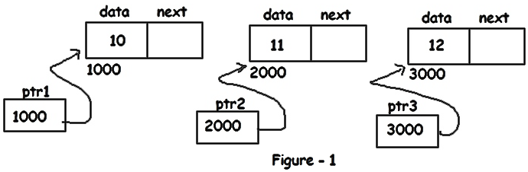

- Assuming that the three nodes of figure-1 already exists, develop a code snippet that connects the three nodes as shown in the figure-2 and display the data values 10, 11 and 12 only using the pointer variable ptr1. (4M)
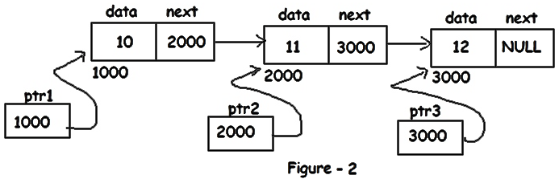
- Continuing with figure-2, develop a code snippet that brings changes in the nodes such that it appears as given in figure-3. Also display the data values 12, 11 and 10 using ptr1 only. (6M)
